5th March 2019

**YOKOHAMA to launch “ADVAN NEOVA AD08RS” with specifications dedicated for European market**

YOKOHAMA announced today the latest addition to its global flagship ADVAN brand. The “ADVAN NEOVA AD08RS", a street sports tyre, will be marketed in Europe only from this spring. The Company plans to gradually make the tire available in 31 sizes, ranging from

185/55R15 82V to 255/30R19 91W.   
  
A re-engineered version of the “ADVAN NEOVA AD08R”, the “ADVAN NEOVA AD08RS” has been fine-tuned to meet Europe’s ECE R117-02 S2WR2 regulation* and raise its environmental performance. While keeping the tread pattern that earned the “ADVAN NEOVA AD08R” a strong reputation for excellent control in dry and wet conditions and superior abrasion resistance, the “ADVAN NEOVA AD08RS” uses a new compound that reduces rolling resistance. The new tyre achieves an excellent handling and low fuel consumption that will fully satisfy driving enthusiasts craving for “speed & fun”.   
* ECE R117-02 is an international standard established in June 2010 by the UNECE (United Nations Economic Commission for Europe) that stipulates technical requirements for tyre noise, rolling resistance and wet grip performance.   
  
YOKOHAMA has established its hobby tyre strategy as one of core elements of the broader consumer tyre strategy included in the Company’s three-year medium-term management plan, Grand Design 2020 (GD2020), implemented from 2018. In line with its hobby tyre strategy, the Company is accelerating the development of new products and expanding the size line-up of existing products suitable for use with various types of hobby vehicles, from race cars to classic cars.

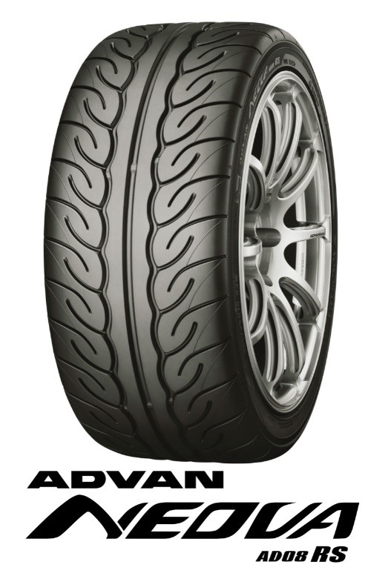

*ADVAN NEOVA AD08RS*

##### *Sizes to be gradually rolled out*

